Name:- T.satya jayanth

Mail id:- [satyajayanth82@gmail.com](mailto:satyajayanth82@gmail.com)

Phn no. 9949570578

Day-4 Assignment

**Question 1:**

Find out the mail servers of the following domain :

Ibm.com

Wipro.com

Solution:-

1. Open run and type cmd in the pentester 2016 version
2. Run as administrator
3. Type nslookup
4. Type set type=mx
5. Now we have to give our mail servers (ibm.com , wipro.com)

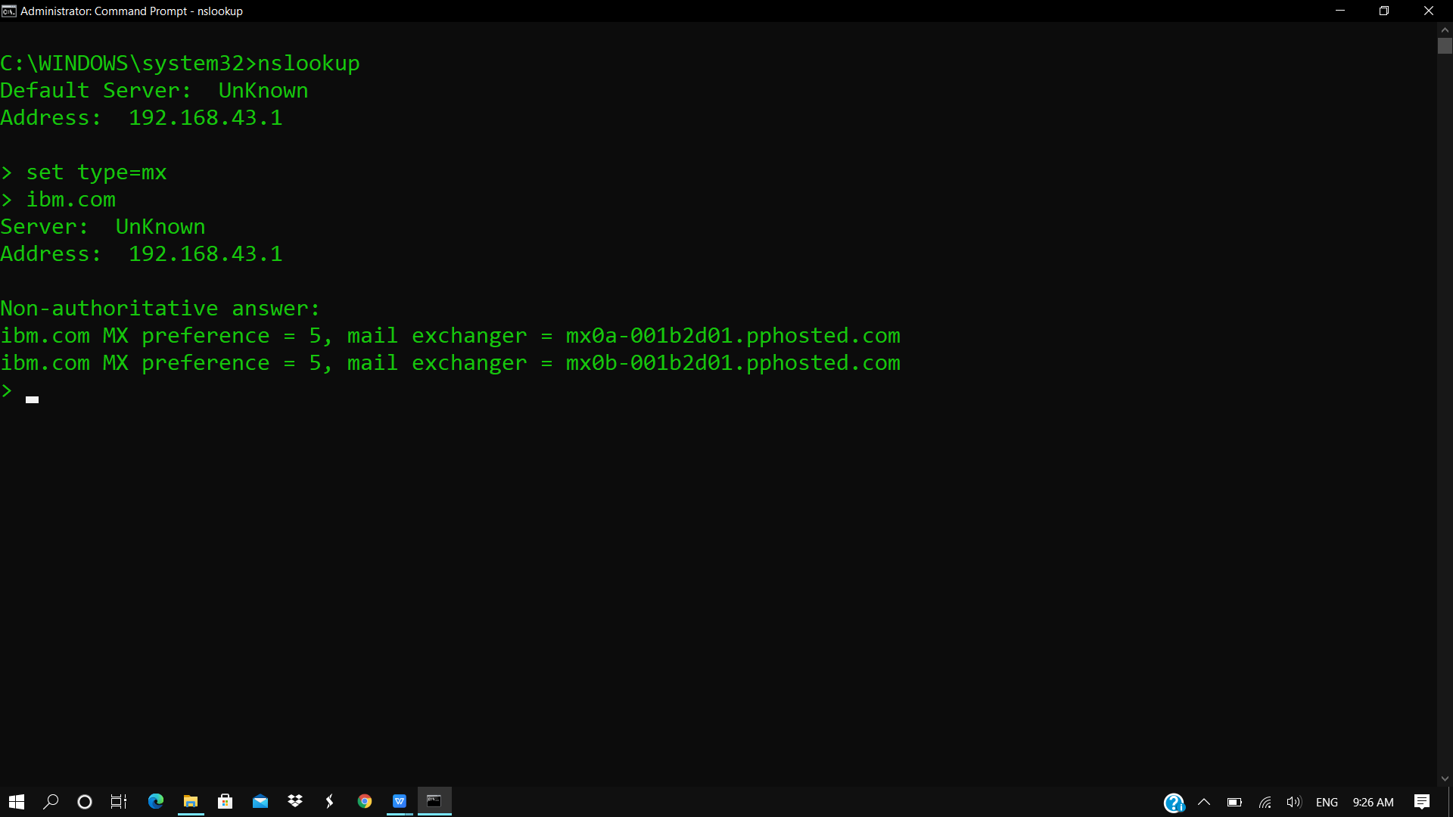

Wipro.com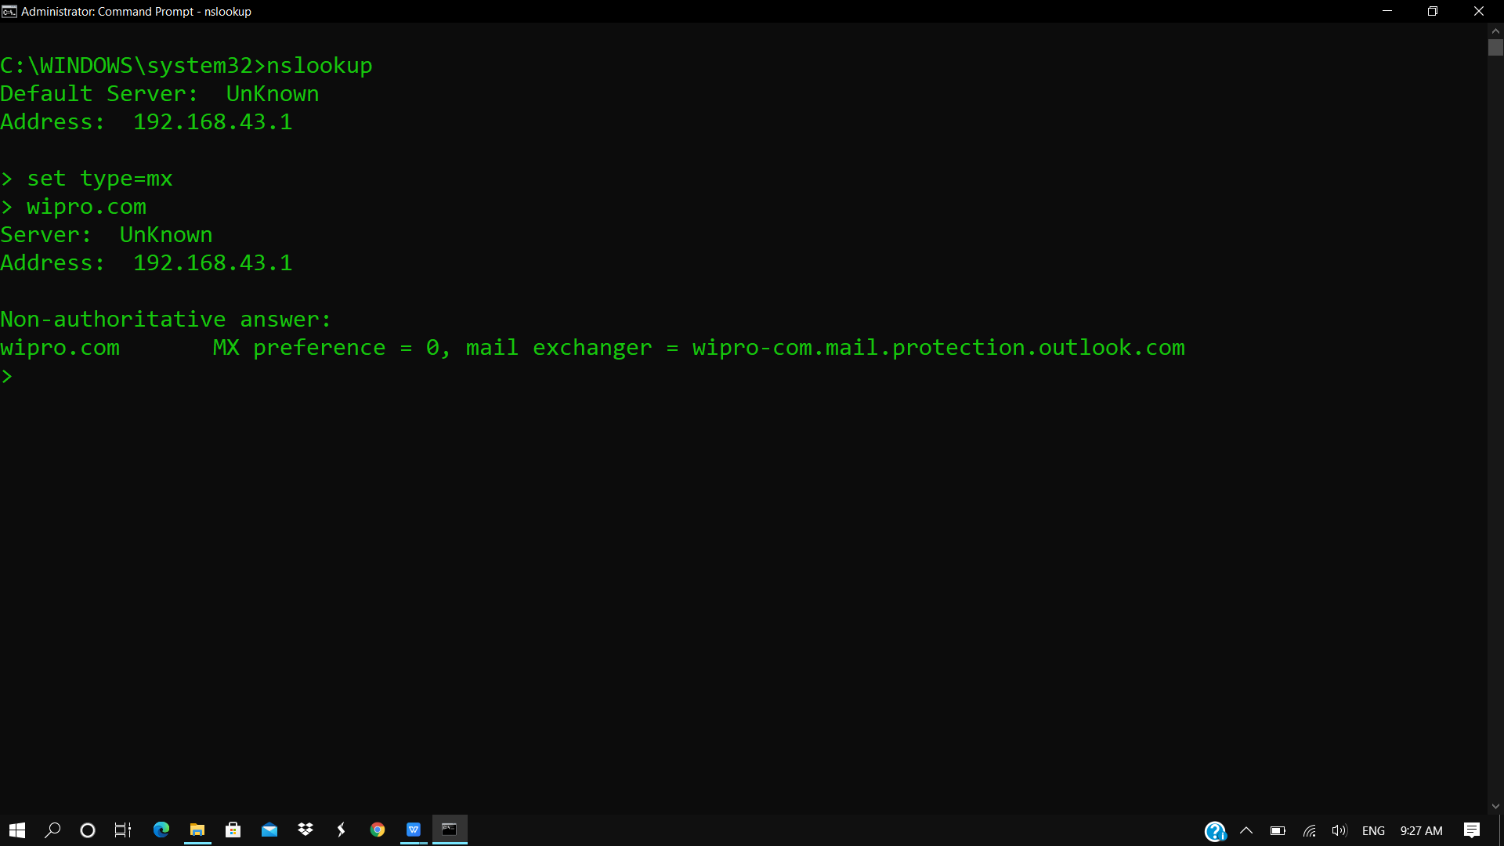

**Question 2:**

Find the locations, where these email servers are hosted.

Solution:-

1. The locations of these 2 email addresses are   
   2) ibm.com - 129.42.38.10

3)Wipro.com - 209.11.159.61

4) type nslookup and type the server now you will get ip address(thats the location ).

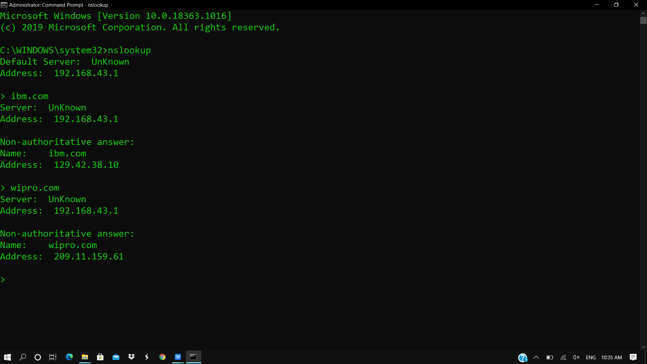

**Question 3:**

Scan and find out port numbers open 203.163.246.23

Solution:-

1. open kali linux through vmware
2. Run as root
3. Open the terminal of kali linux
4. Type nmap -Pn -sS 203.163.246.23
5. But in this ip all are filtered it means , All the hosts are under firewall or some security connection .
6. 0 hosts are opened in this ip
7. 1000 ports are filtered

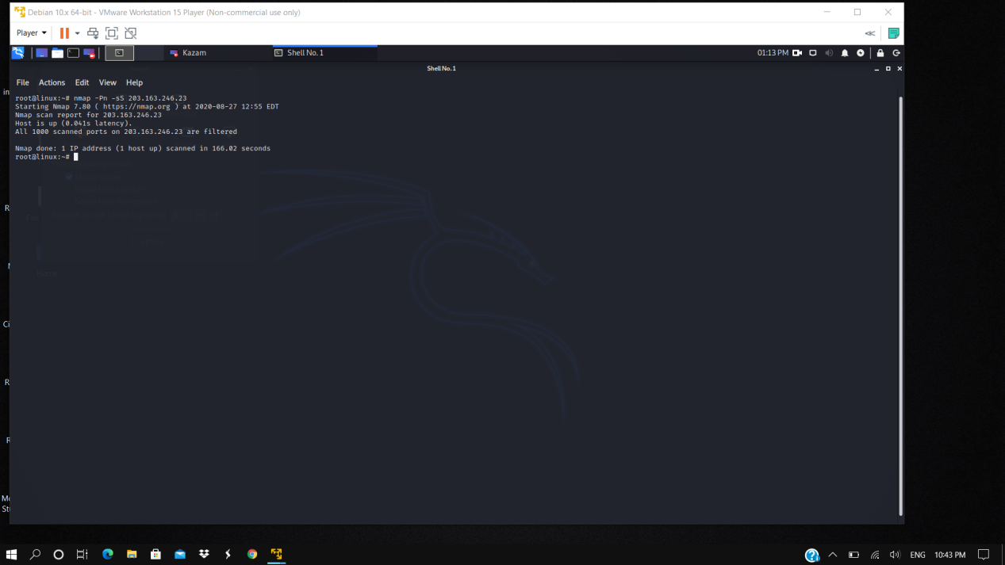

This is just for extra information

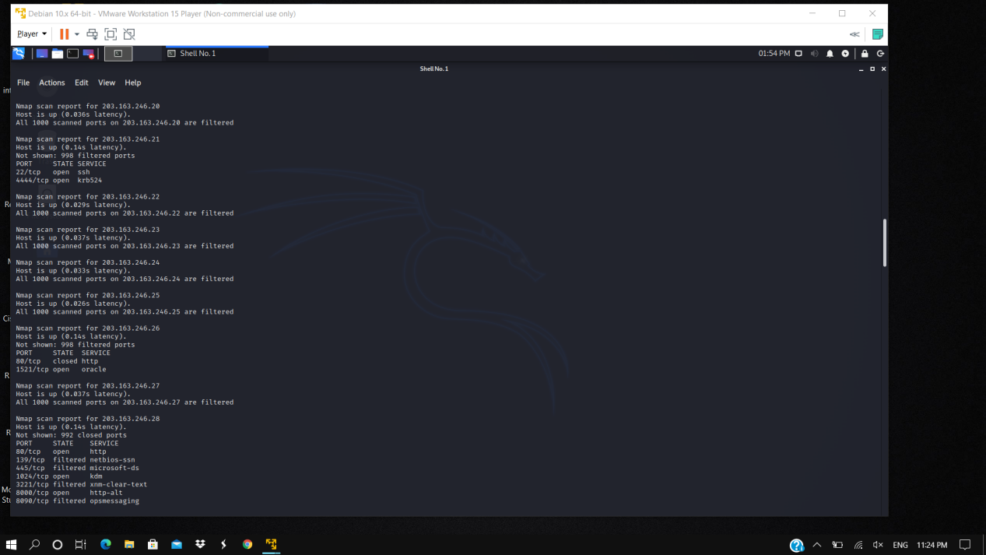

**Question 4:**

Install nessus in a VM and scan your laptop/desktop for CVE.

Solution:-

1. open pentester 2016 version
2. In browser type nesus essentianls ,after all credentials download the specified bit
3. Now open the nessus essentials
4. Go to new scan and click advanced scan
5. Give name and target details
6. Go to credentials and type Administrator details
7. Now launch it

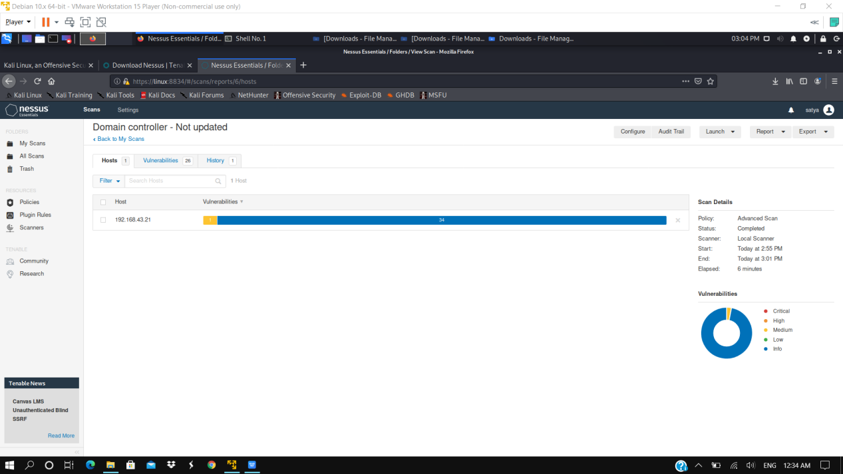

8)We will get cse file in html or pdf



I attached html and pdf format

If u have any problem to open this 4th question pdf and html file   
am keeping in this folder also once check that   
   
 Thank u